 | Western Civilization from Prehistory to 1650  Dr. Edrene S. McKay  (479) 855-6836  Email: esm@online-history.com

TUTORIAL FOR EDITING "MIDDLE AGES" POWERPOINT PRESENTATION: FOR POWERPOINT USERS

These files have been uploaded to Online-History.com:

File Name | Content | File Size
The Middle Ages.ppt | Original presentation (94 slides) | 5766 KB (5.8 MB)
The Middle Ages-Blank.ppt | A blank presentation that has the original design | 54 KB
The Middle Ages-1.ppt | Slides 1-10 of original presentation (see handout) | 597 KB
The Middle Ages-2.ppt | Slides 11-20 | 437 KB
The Middle Ages-3.ppt | Slides 21-30 | 966 KB
The Middle Ages-4.ppt | Slides 31-40 | 860 KB
The Middle Ages-5.ppt | Slides 41-50 | 828 KB
The Middle Ages-6.ppt | Slides 51-60 | 930 KB
The Middle Ages-7.ppt | Slides 61-70 | 387 KB
The Middle Ages-8.ppt | Slides 71-80 | 616 KB
The Middle Ages-9.ppt | Slides 81-94 | 510 KB

If you can download and work with the original file (it's 5.8 MB), you won't have to manage as many files. However, if you have a dial up connection, you may have difficulty downloading such a large file. Consequently, I broke the original down into smaller segments that are all under 1 MB. You should be able to handle these smaller files easily.

There is also a blank file that contains the design of the original presentation. You will want to use this because if you start with a new presentation, you'll lose the "look" of the original when you copy and paste slides from the original file(s).

Here are some technical tips for editing the presentation:

- If you're going to use the nine smaller files, label the slides on your handout so you know where to find them when you want to use them.
- Start by opening the blank file that contains the design. The window will look like this. Ignore the "Click to add first slide" message and open one or more of the original files.
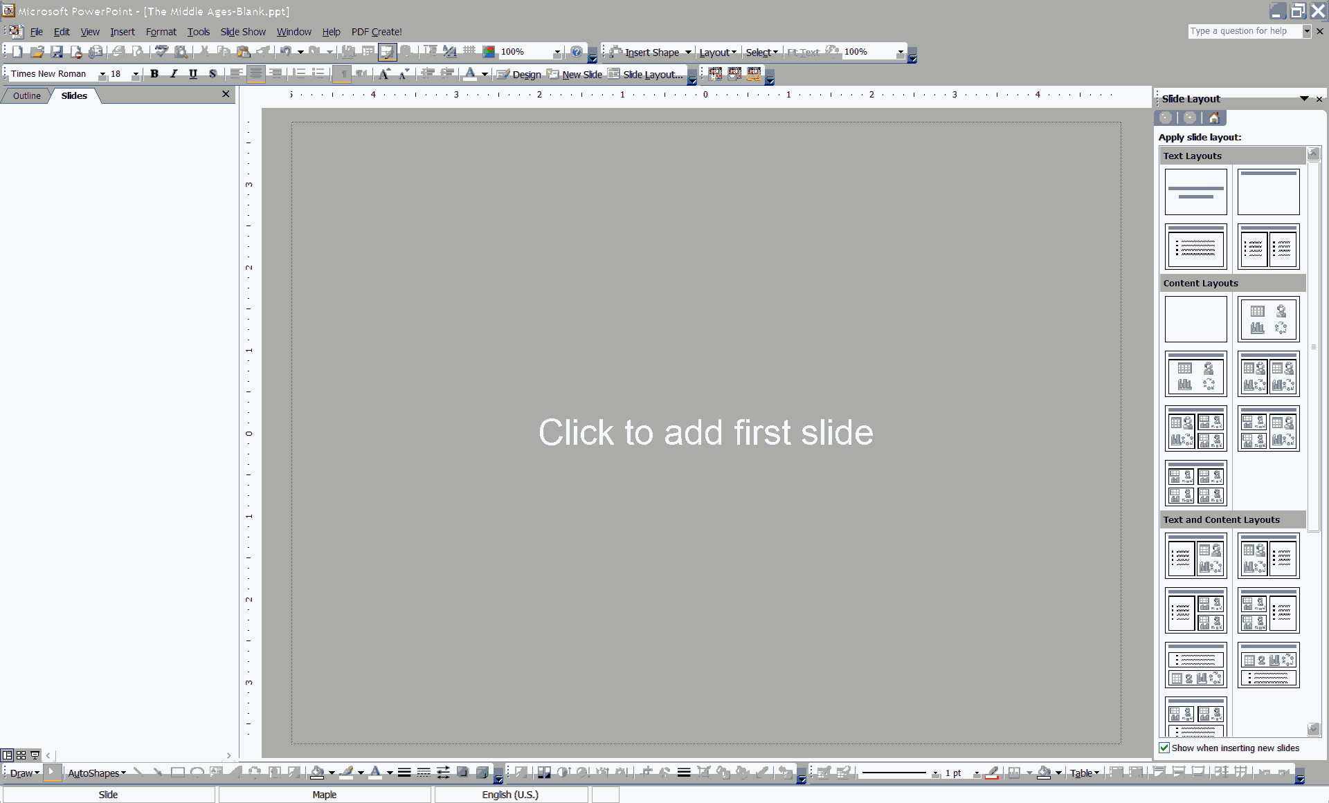

- In Normal view, select the thumbnails of the slide or slides in the original that you want to use. Hold down your Shift key to select the first and last slides of a contiguous group (e.g., Slides 1-3). Hold down your Control key to select slides that are not contiguous (e.g., 1, 3, 4). You'll note the colored border tells you they have been selected. Then right click in one of the selected slides and select Copy.

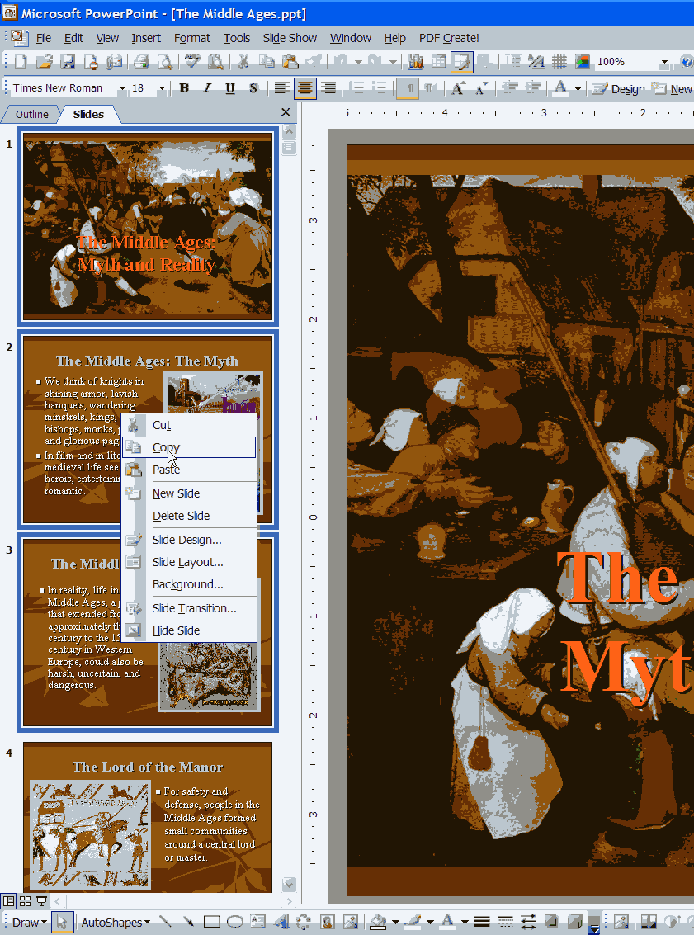

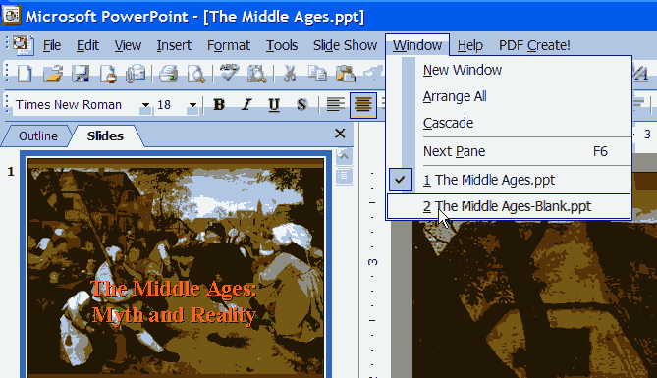
- To go back to the Blank presentation, select the file name from the menu item Window.

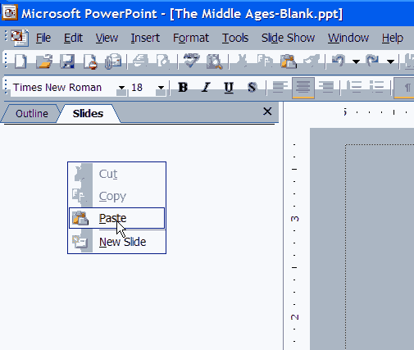
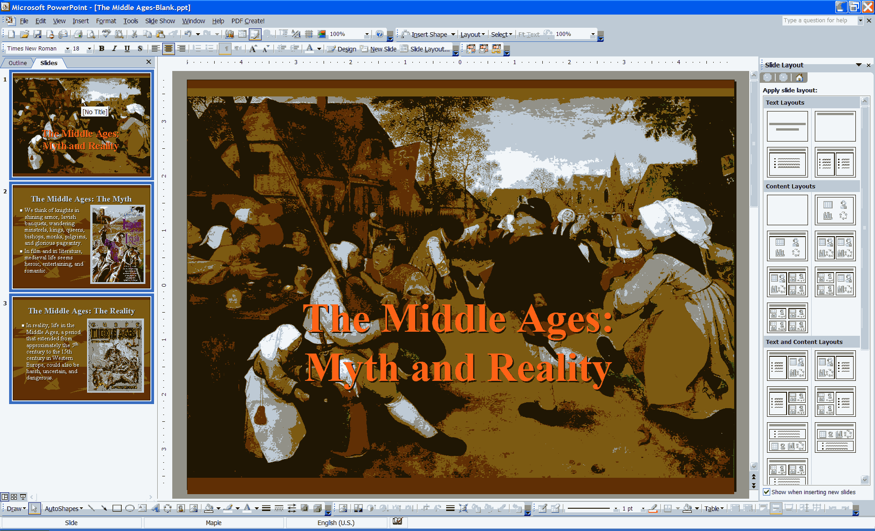
- Right click in the white area where the thumbnails will appear and select Paste. The slides you selected in the original presentation will be pasted here.

- Continue copying and pasting from the original presentation file(s) until you have everything you need.

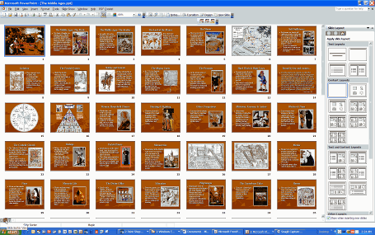
- You might also want to rearrange slides. The easiest way to do that is in Slide Sorter view.

- Select the slide you want to move (i.e., Slide 11 entitled "The Magna Carta"). It's border will be highlighted in color. Then drag it to its new location and drop it there. The other slides will shift to make room for it.

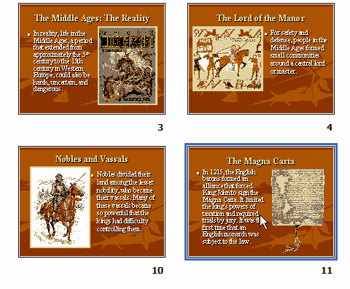
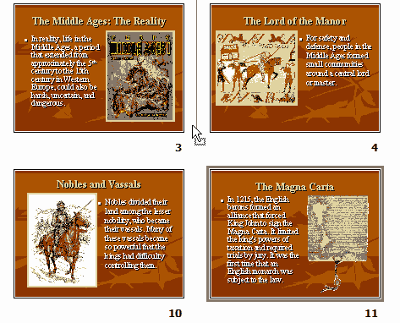
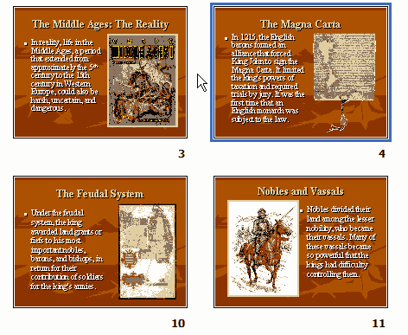

- When you have finished your first edited presentation, save it with a new file name so you can use the blank presentation again. To do this click on the menu item File, Save As. When the dialog box opens, carefully select the part of the file name you want to change (i.e., "Blank").

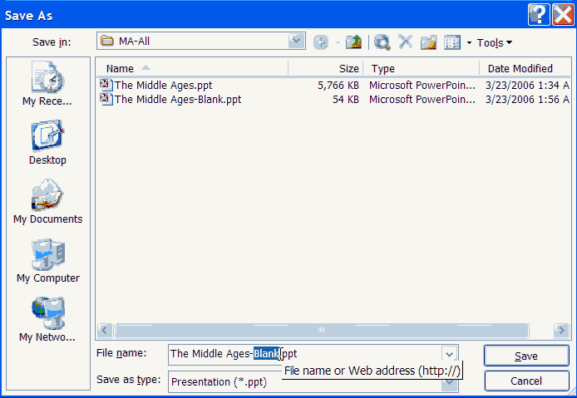

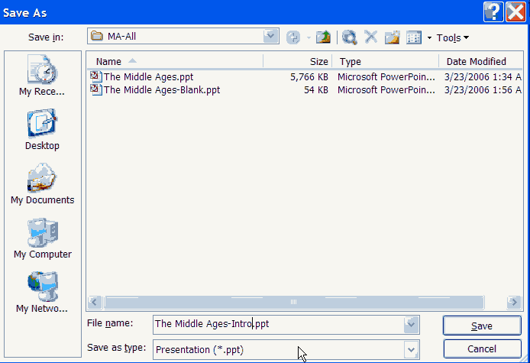
- Finally, type a new name (i.e., "Intro" and click on Save.

