 | Western Civilization and United States History  Dr. Edrene S. McKay  (479) 855-6836  Email: esm@online-history.com

GUIDELINES FOR THEMATIC ESSAYS AND PRESENTATIONS

The purpose of these essays and presentations is to give you an opportunity to share the results of your research on one of four major historical themes (American Political Democracy, American Society, the American Economy, and American Foreign Policy). As you do that, it will also be possible to learn about agents of constructive change and to showcase primary source documents (i.e., eyewitness accounts of history). We will be following the model established by the "Eyewitness to History" website at http://www.eyewitnesstohistory.com. A good example is “Christopher Columbus Discovers America, 1492.” Please click on the link now to see the components, length, and format of the essay. You will note that it is quite short and that it's purpose is to highlight the primary source, which is Columbus' journal.

Your purpose will be slightly different. You are trying to answer a question or series of questions about your theme (see "Major Themes in United States History" for the questions) and need to select a primary source that will illuminate that theme. If you can focus the essay on a person who played a significant role in connection with the primary source, all the better. These guidelines are written with the hopes that you can make your essay biographical. If that's not possible, substitute "document" or "event" for "character" throughout these guidelines. But you must showcase a "primary source" in the essay.

RESEARCH
You may use any resources at your disposal (including the Internet, which is rich in primary sources). To locate a primary source, use Google.com as your search engine and this format (be sure to include quotation marks):

“Christopher Columbus” +”primary source”

As you collect information from the Internet, you will need to evaluate the websites you plan to use. There are a number of resources that can help us do that:

- Q&As from the University of California at Berkeley on evaluating websites: http://www.lib.berkeley.edu/TeachingLib/Guides/Internet/Evaluate.html

- From Iowa State University’s e-library: http://www.lib.iastate.edu/commons/resources/evaluation/

- From Mt. San Antonio College Library: http://www.mtsac.edu/college/ltc/library/research/help/credible.html

- Robert Harris’s guide:
http://www.virtualsalt.com/evalu8it.htm

- University of Southern Main’s Checklist: http://library.usm.maine.edu/guides/webeval.html

- Comparing websites for a credibility check:
http://novel.nifl.gov/susanc/fool1.htm

I highly recommend the University of California resource (the first on the list) because it provides a comprehensive and systematic approach to the subject. I especially like the questions/implications format it uses (see next page for a screen capture):

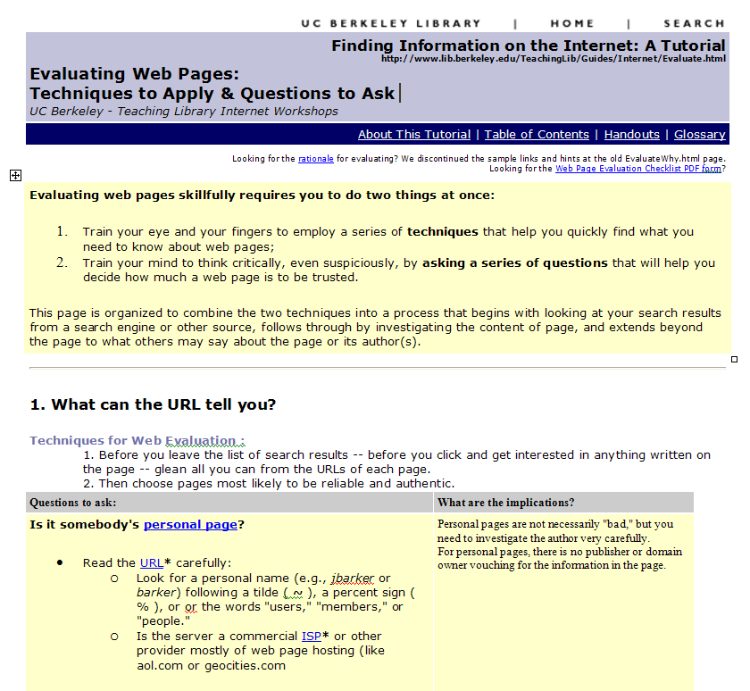

When you have gathered all the material you need for your essay (background information, interesting facts for sidebars, illustrations, and references), you’re ready to begin creating your essay.

ESSAY COMPONENTS

- Essay Title
Be creative. An interesting title captures the attention of your audience and gives readers a clear idea of the subject of your essay. Be sure to include the date that your primary source was written.

- Introduction to Subject
Here’s where good research pays off. You will want to achieve these objectives:

- Identify your character (include biographical information, character traits, special achievements)
- Analyze his or her historical significance (importance to Western Civilization or United States history)
- Explain how he or she served as an agent of constructive change (made significant improvements to society, the nation, or the world).
- Set the stage for the primary source you are showcasing (put it in its historical context)

- Sidebars/Text Boxes
These can be highlights taken from the introduction or the primary source. Or they can be other interesting facts
related to the subject which do not appear in the text.

- Illustrations
You are likely to find pictures at websites on your topic. Just right click on the picture and copy and paste it into your document. However, you can also use Google.com to find illustrations by clicking on “Images” before you hit the search button. Click on the thumbnail to get a full size image before copying and pasting.

- Primary Source
Copy and paste all or part of the primary source into your document. Under ordinary circumstances, your entire essay (including the primary source) should not exceed three pages; however, I would like to see it even shorter than that. That means you might need to condense the original source so that you include only the most important parts. If you do eliminate phrases, sentences or paragraphs, be sure to substitute three periods (…) for a missing phrase or four periods for missing sentences and paragraphs (….). Use quotation marks, italics, or a unique text color to set the primary source apart from the rest of the document.

- References
This is an alphabetized list of references that contributed to your sketch. Please divide the list into two categories (primary sources and secondary sources) and use the MLA reference style. EasyBib.com (http://easybib.com) provides a free service which enables you to type the components of your reference into a dialog box and it creates an MLA bibliography entry. You merely copy and paste it into your bibliography.

- More Information
This section is not included in the example. However, you can usually find interesting, informative, or entertaining references that did not necessarily contribute to the content of your essay, but that your audience would enjoy exploring, please list them here. For example, if your topic is the Salem Witch Trials, National Geographic has a Salem Online Witch-Hunt Game that readers might enjoy. The URL is http://www.nationalgeographic.com/features/97/salem.

- Credits
Here’s where you take credit for your essay. Please use this format: “This sketch was prepared by Firstname Lastname, College, Date.”

PRESENTATION

Focus
While your essay will focus on a single primary source related to your theme, your presentation should focus on the theme and answer one or more questions related to the theme using the primary source and information from your essay to illustrate your answer. The presentation gives you an opportunity to be highly creative in your approach to the subject.

Format
To enable everyone in the class to see your presentation, you should use either Microsoft PowerPoint or StarOffice Impress to create your presentation. Include both text (no smaller than 18 pt type) and pictures and one of the designs in the program.

You have considerable flexibility in how you go about creating your presentation, however, be sure that it shows the results of your research and illuminates the theme.

Length
Under normal circumstances, it should not contain more than ten slides, however, this is negotiable. If you think you should have more than that, I would like to see a draft before I approve the length.

