 | United States History to 1877  Dr. Edrene S. McKay  (479) 855-6836  Email: esm@online-history.com

WEEK THREE DISCUSSION: THE ENGLISH TRANSPLANTATION
For Debate: Historians frequently see patterns in historical developments that the lay person does not. For example, one historian observed that the English colonists who came to America experienced “soaring expectations, frustration, disaster or near disaster, and then slow adjustment to the grinding realities of life on the wilderness edge of the North American continent.” Does this pattern hold true for Virginia, Massachusetts, and Pennsylvania? Or is there a better way to describe the common experience of these early English colonists?

This question will be the subject of our discussion this week. To arrive at a conclusion, we will need to consider each of the following:
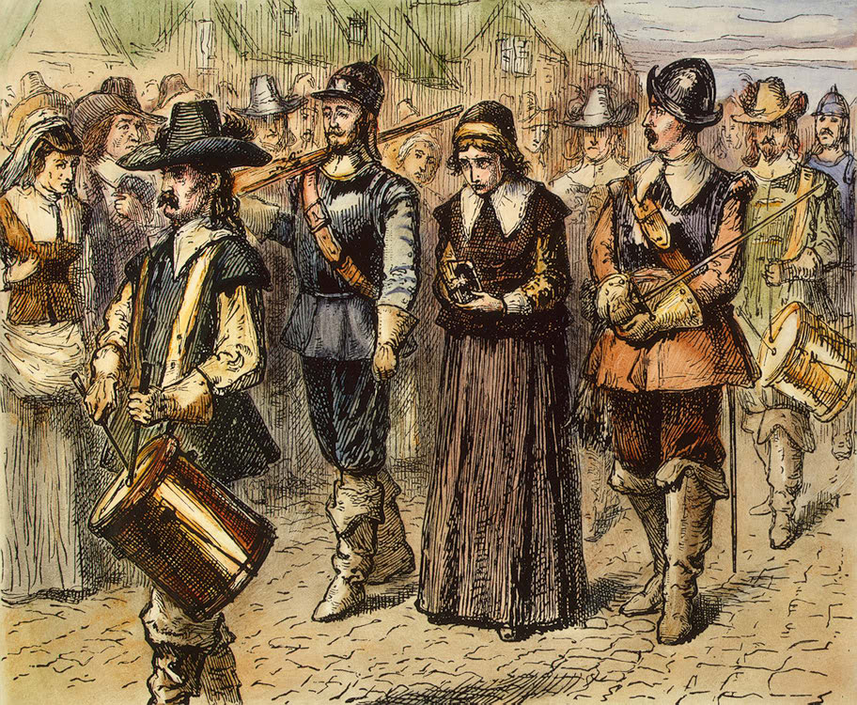
- First, what were the principal differences between the English colonies and the Spanish and French settlements? (See Topic 2.3. Spanish, French, and English Settlement)
- Second, what motives did the colonists from Virginia, Massachusetts, and Pennsylvania have for coming to the New World? Did they have a common purpose? Or were their motives quite different? What expectations did each group have for the New World?
- Third, did the New World live up to their expectations? Or did they all run into serious difficulties? What social, political, economic, or religious problems, if any, did each of these groups encounter?
- Fourth, how did each colonial group finally adjust to the New World? Is it possible to identify one or more turning points for each? Were there any compromises involved in their adjustment? How did each group define success in the end?
- Fifth, is there a common thread that runs through the stories of these early English colonists?

Summation: What is your conclusion? Is the pattern “soaring expectations, frustration, disaster or near disaster, and then slow adjustment to the grinding realities of life on the wilderness edge of the North American continent” the best way to explain the experience of colonists from Virginia, Massachusetts, and Pennsylvania? Or is there a better way to describe the common experience of these early English colonists?
Use effective communication techniques when you share your ideas, insights, and discoveries with others.

