 | Western Civilization Since 1650  Dr. Edrene S. McKay  (479) 855-6836  Email: esm@online-history.com

WEEK THREE: THE ENGLISH REVOLUTION
For Debate: Many historians have argued that there is a common pattern in the way political revolutions occur. Revolutions seem to pass through four distinct phases:
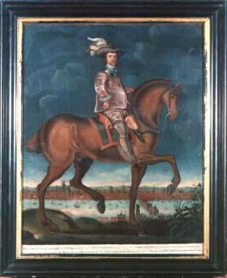
- During an initial period of agitation, reformers seek changes in the status quo. The goals of the reformers are moderate and they are willing to tolerate much of the existing governing structure if certain changes are implemented. The leaders of the reform movement often include members of the governing class. Opposition by the government to reform, however, makes the reformers increasingly radical.
- During the second phase, the reformers become revolutionaries. They seek and achieve the overthrow of the government. Revolutionaries establish and strengthen an entirely new government based on the principles of the revolution. Conflict often emerges between the original leaders of the revolution and those seeking more radical change.
- During the third phase, the fervor of revolutionaries reaches its most extreme level. Revolutionary ideology is put into practice in ways which are heedless, oppressive, or impractical. Seeking to preserve and extend the accomplishments of the revolution, revolutionaries try to destroy all enemies of the revolution. In so doing, the revolutionaries ironically become more oppressive than the government they overturned.
- During the last phase, the populace reacts against excesses of the revolutionaries, removing the most recent leaders and returning to government some pre-revolutionary practices and leaders. Most of the changes of the revolution, especially those of the early phases of the revolution, remain in place however.
How well does this pattern describe the English Revolution? To arrive at a conclusion, we will need to consider each of the following:
- First, what problems emerged during Elizabeth I's reign and how was she able to maintain peace? How did her actions set the stage, however, for conflict during her successors' reigns?

- Second, how did the reformers achieve the overthrow of the government?

- Third, what stage of the revolution do you consider to be most radical?
- Fourth, how did the populace react against the excesses of the revolutionaries?
- Summation: What is your conclusion? How well does this pattern describe the English Revolution? Is there another pattern that describes it better?
Use effective communication techniques when you share your ideas, insights, and discoveries with others.

