 | Western Civilization from 1650 to the Present  Dr. Edrene S. McKay  (479) 855-6836  Email: esm@online-history.com

WEEK FOUR: THE EARLY MODERN ECONOMIC REVOLUTION.

For Debate: In the late eighteenth century, a French philosopher, Abbé Raynal offered a prize for the best answer to the question: "Was the discovery of America beneficial or harmful to the human race?"

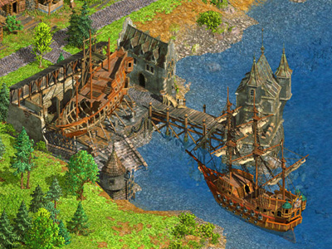
This question will be the subject of our discussion this week. To arrive at a conclusion, we will need to consider each of the following:
- First, the legacy of Christopher Columbus and the Spanish Conquest of the New World.
- Second, the differences in the social structure, political system, economic system, values and religious life of Medieval Europe and Modern America.
- Third, the conditions in Europe that provided motives for British colonization of the New World.
- Fourth, the role that colonial settlement played in Wallerstein's Modern World System.

Summation: What is your conclusion? Was the discovery of American beneficial or harmful to the human race? Explain your answer.
Use effective communication techniques when you share your ideas, insights, and discoveries with others.

